Is sitting new smoking? How to reduce sitting at work?

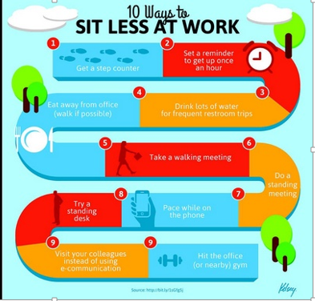

Most jobs today are sedentary, requiring people to sit for long periods of time, even though there is growing interest in being more active. This is getting worse as advances in technology and increased peer pressure mean that many people do not leave their desk, even for communicating with their colleagues. Although doing the recommended levels of physical activity of 150 minutes of moderate-intensity aerobic exercise each week and resistance exercises twice a week outside of work can help, this is not enough. There is still an increased risk of premature mortality, cardiovascular disease, obesity and diabetes if one sits for prolonged periods.

A Cochrane review titled “workplace interventions to reduce sitting at work” (1) looked at ways to make it easier for people to sit less at work but, when we think of an average office, we can see how reducing sitting is a huge challenge. It might need changes to the architecture, new furniture, or changes in the office routine, which can be expensive and disruptive. This makes it even more important to find out that whether interventions that aim to reduce sitting, such as desks at which you can work while standing, actually do reduce sitting. The authors found some evidence that it might be possible to make a difference.

The authors searched a wide range of scientific literature and agreed on 8 studies that could be included in the review. These studies had been done in a variety of settings: a research institution, an academic institution, a government agency, a police organisation and private organisations; making the population largely representative of office workers. Half the studies were from Australia, and the other half from Europe. They didn’t find any studies from the other continents, or from low- or middle-income countries.

Unfortunately, they felt that all the studies were at high risk of bias and limitations in their study designs and quality, and their inconsistent results made it difficult to interpret the findings.

Three studies investigated the introduction of sit-stand desks, which are height adjustable so that people can work at their desk while either standing or sitting. They found that sit-stand desk with or without information and counselling reduced sitting time by nearly 2 hours per 8-hour workday.

There were two studies of computer prompts to reduce sitting at work, in which the display of periodic prompts is intended to remind and encourage employees to move from their sitting position. However, the results were mixed, with one study showing that the prompts reduced sitting by just under one hour per day, while the other did not find a reduction in sitting time.

The study of policy changes in the worksite that were intended to introduce walking strategies, such as walking during breaks, also found that there was no considerable decrease in sitting and another study of mindfulness training did not have any effect on sitting at work. Finally, a study of counselling by an occupational physician about the risks of sitting for prolonged periods at work showed that this decreased sitting time by about half an hour per day, compared with usual practice.
In summary, this Cochrane Review shows that sit-stand desks can reduce sitting at work, but the quality of evidence is very low. The effects of the other interventions are even less clear and there is a need for high quality research into the effects of the different types of interventions. Thankfully, many trials are being conducted at the moment and the results of these might change our conclusions. However it is recommended that people who sits a lot at work should stand up, if it is safe to do so, and to try to stand up at least once every two hours.”

References
- Shrestha N, Ijaz S, Kukkonen-Harjula KT, Kumar S, Nwankwo CP. Workplace interventions for reducing sitting at work. Cochrane Database of Systematic Reviews 2015, Issue 1. Art. No.: CD010912. DOI: 10.1002/14651858.CD010912.pub2. Available at ow.ly/I0dA5.

